108_vaishnavi Tidke -JH

Task 02

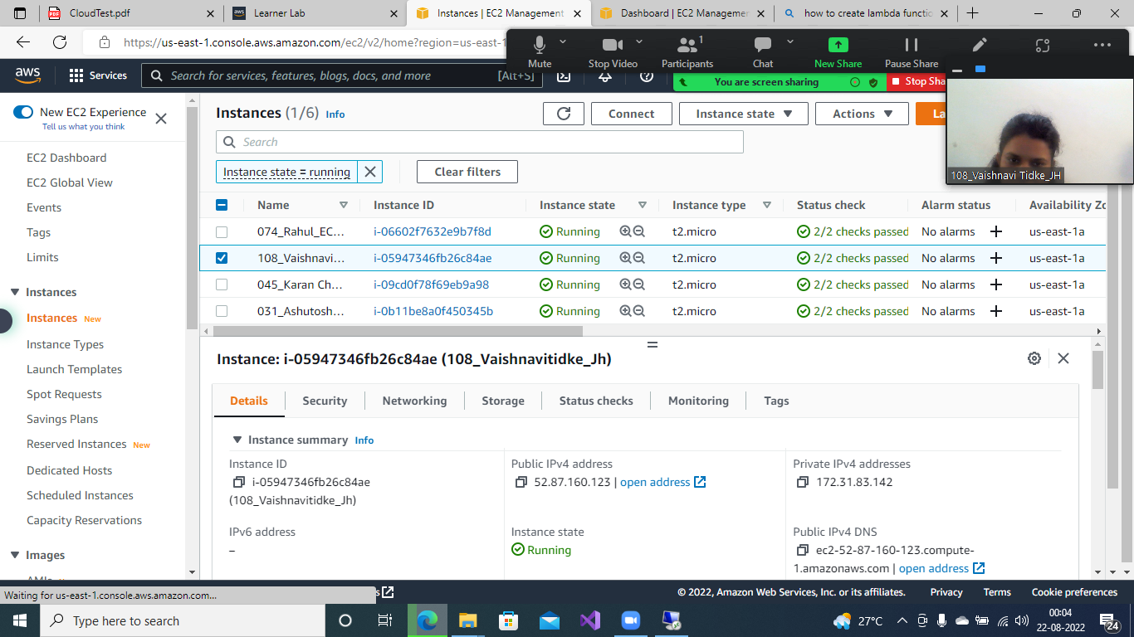

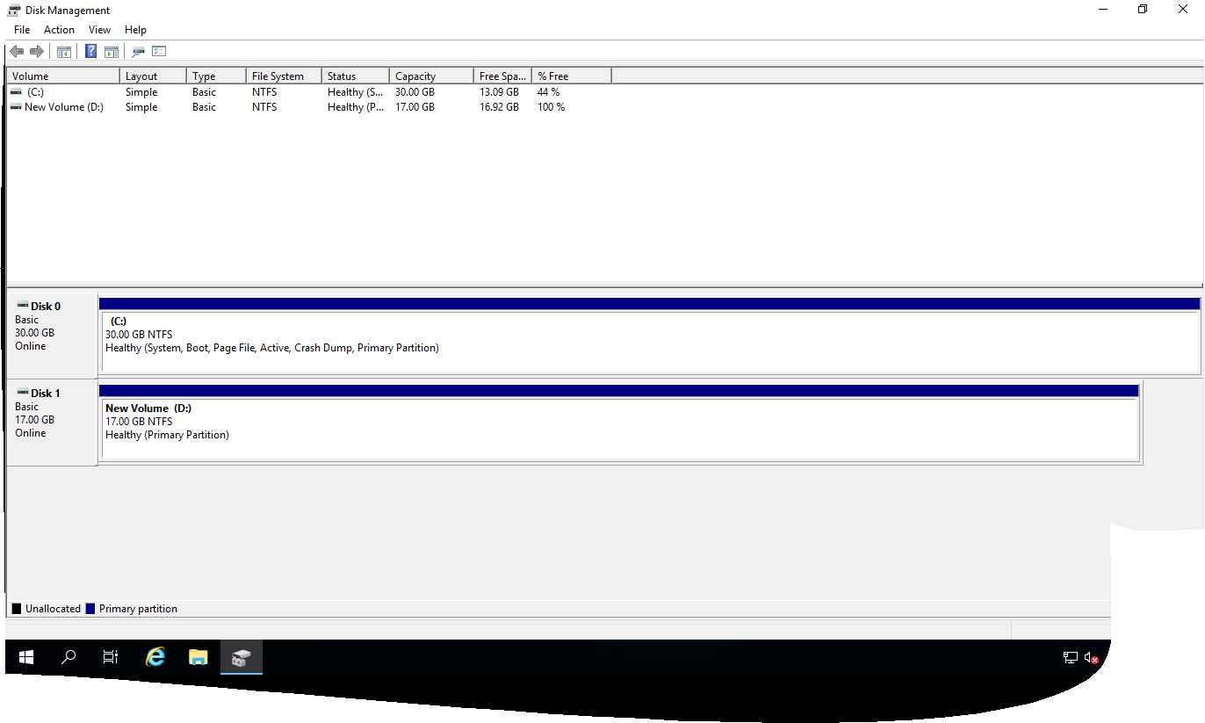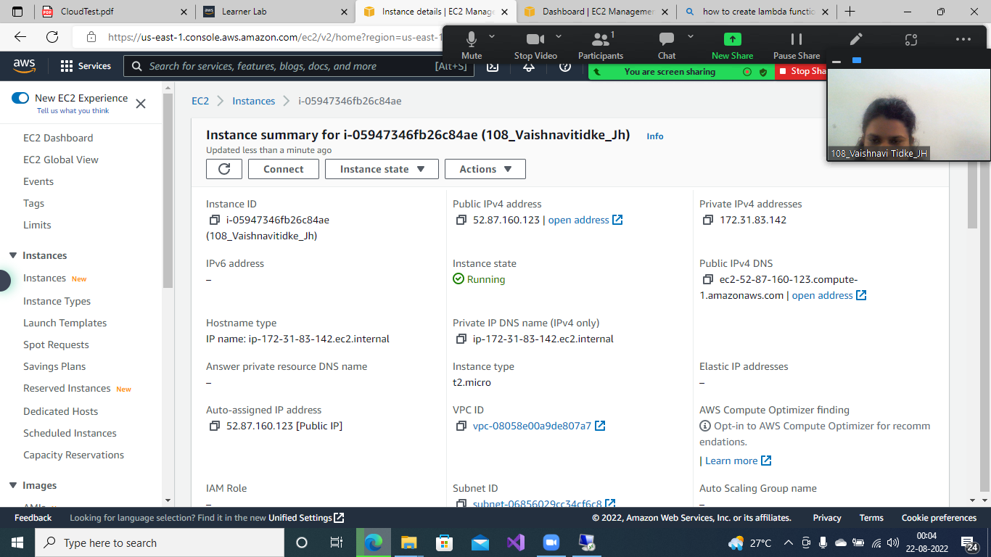

Task 01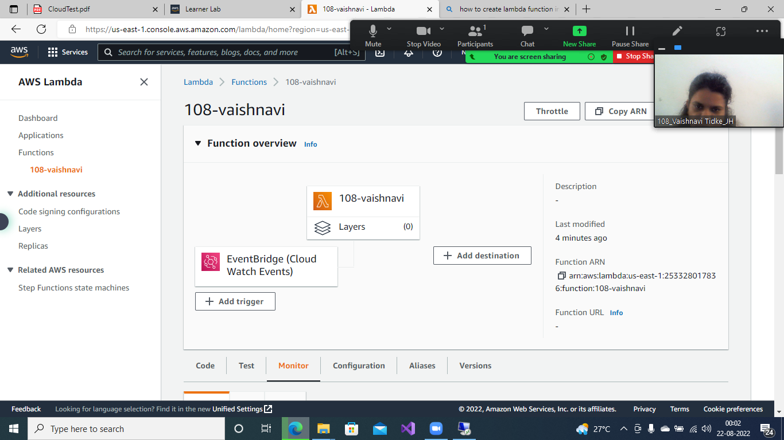

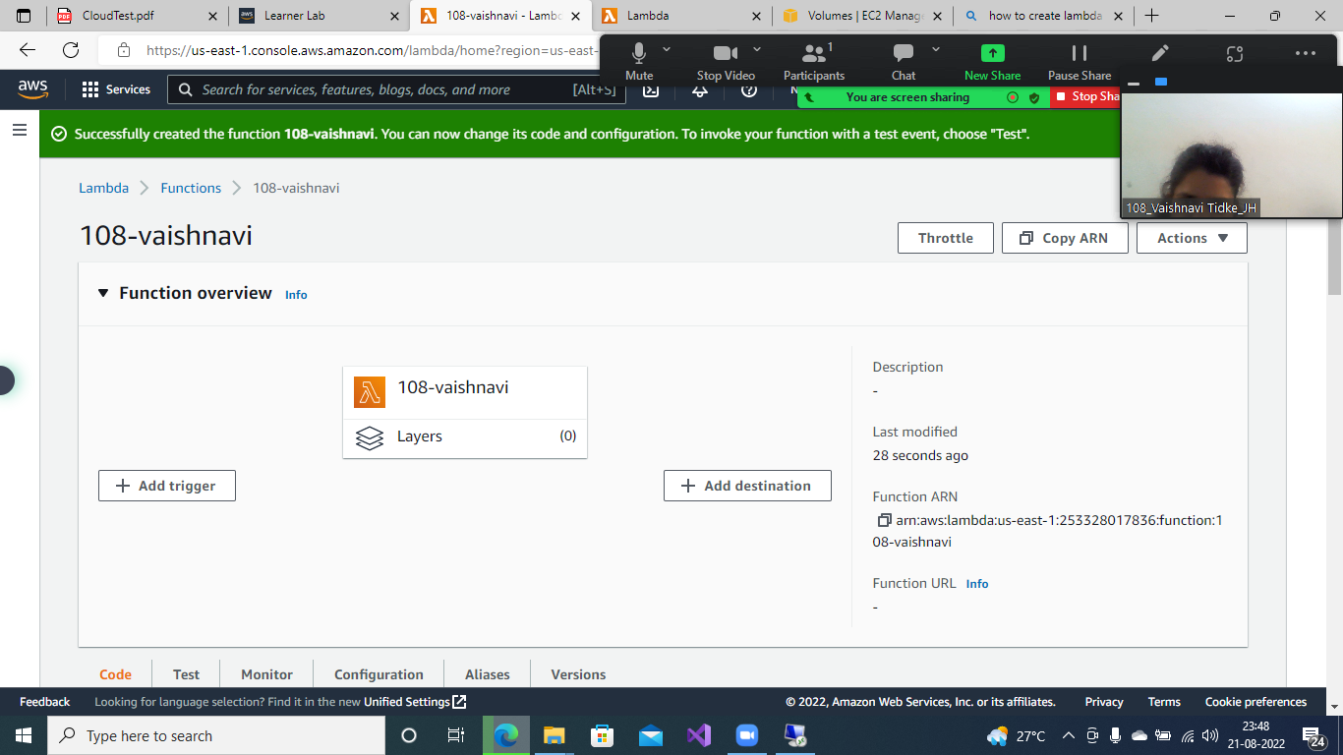

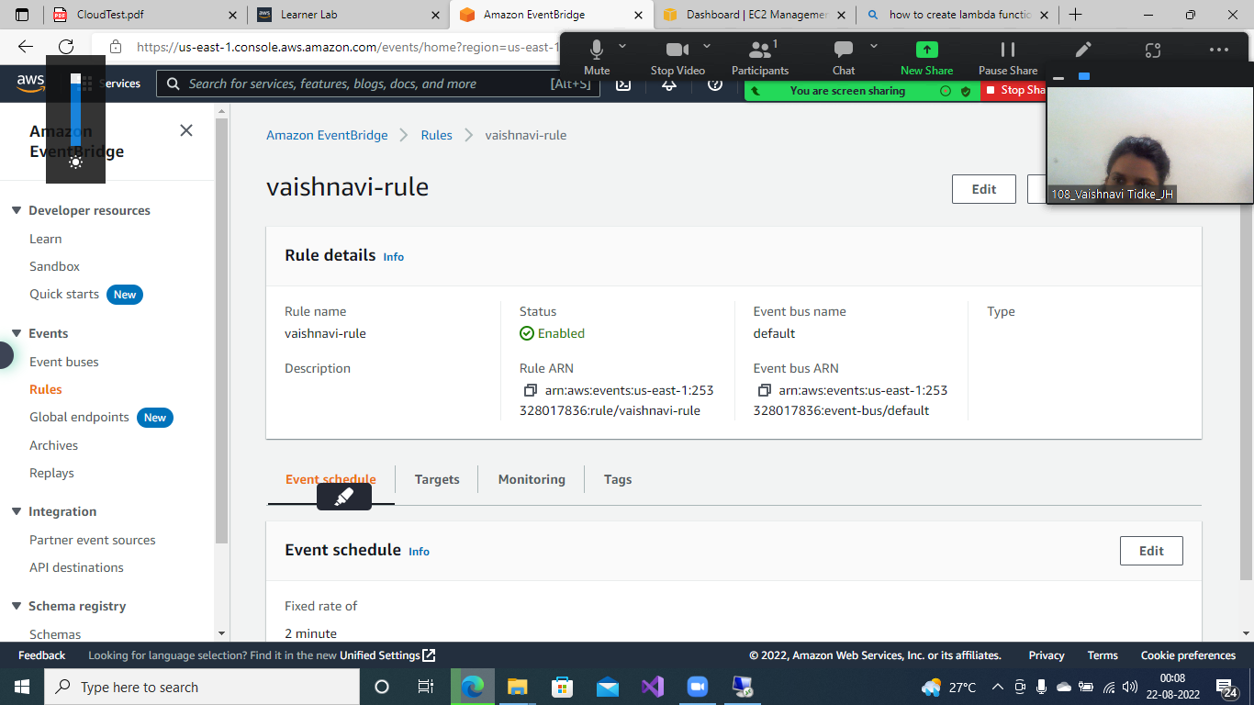

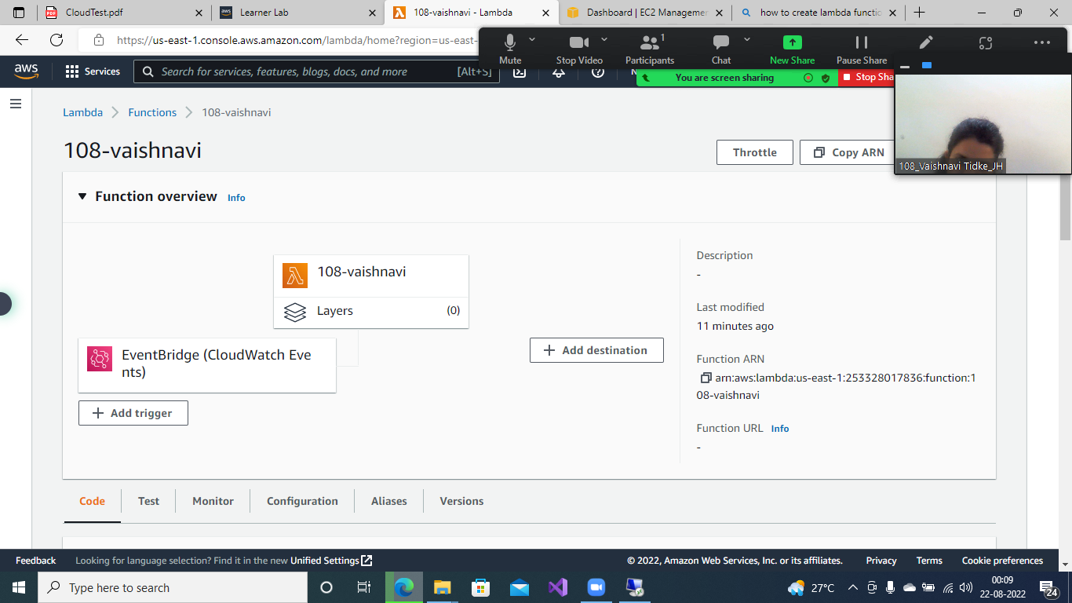

Task 3

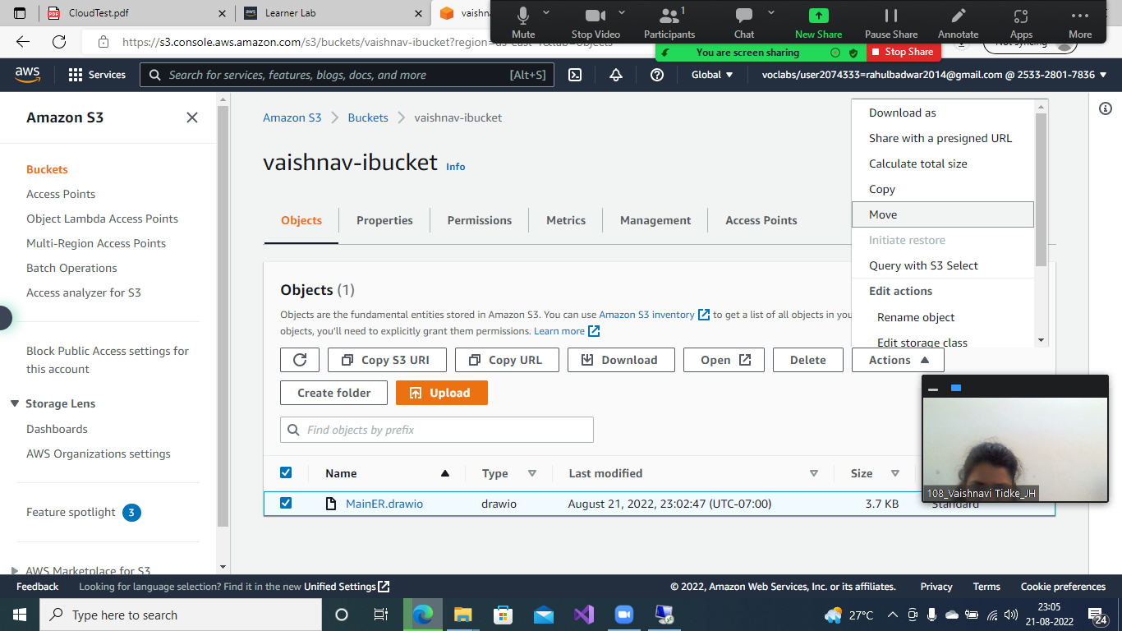

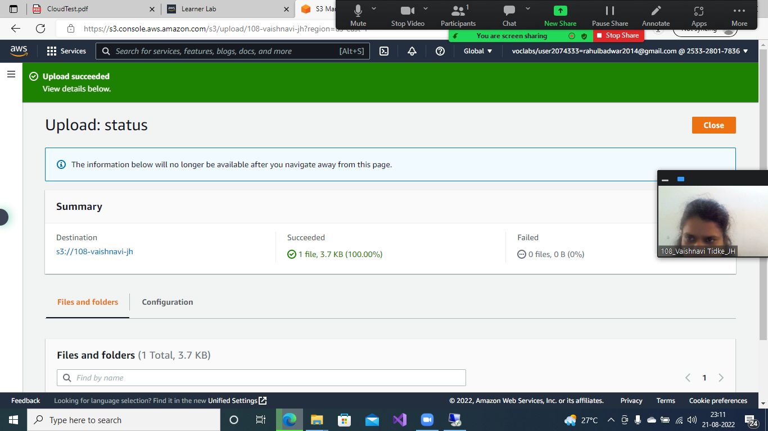

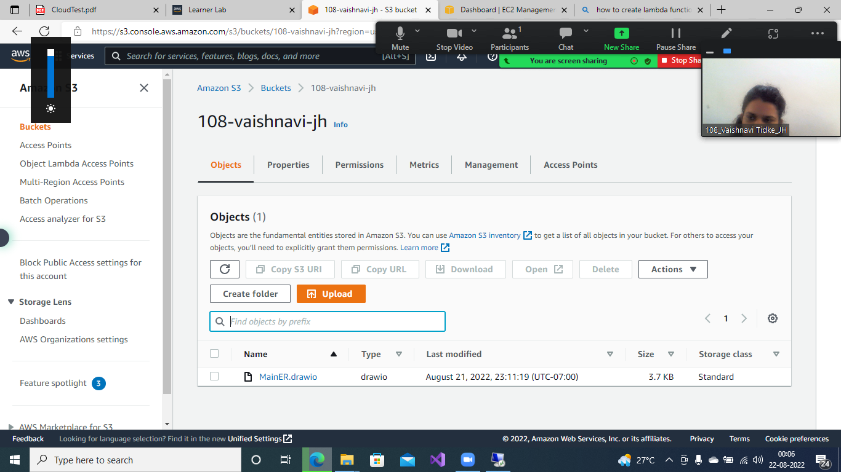

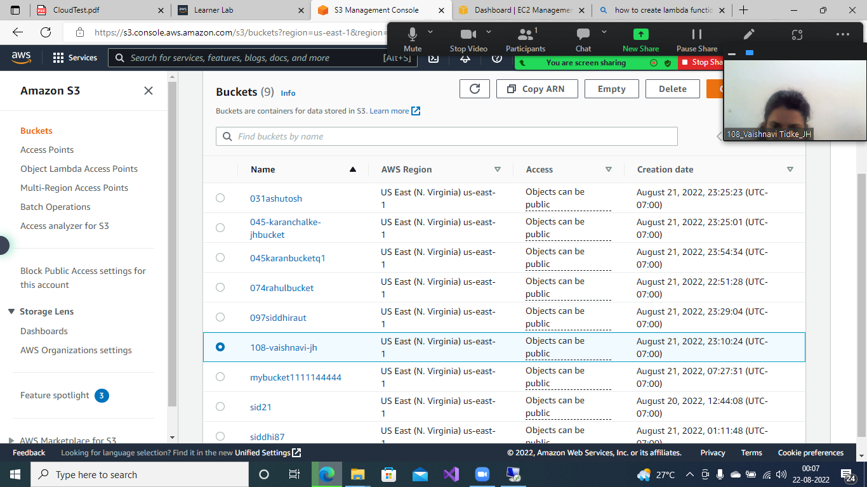

● Describe the role of the Amazon S3 service in big data solutions.:

**:** Amazon Simple Storage Service (Amazon S3) is an object storage service that offers industry-leading scalability, data availability, security, and performance. Customers of all sizes and industries can use Amazon S3 to store and protect any amount of data for a range of use cases, such as data lakes, websites, mobile applications, backup and restore, archive, enterprise applications, IoT devices, and big data analytics. Amazon S3 provides management features so that you can optimize, organize, and configure access to your data to meet your specific business, organizational, and compliance requirements

**Q: Explain how AWS Identity and Access Management (IAM) controls access to Amazon S3**

**Ans:** AWS Identity and Access Management (IAM) is a web service that helps you securely control access to AWS resources. You use IAM to control who is authenticated (signed in) and authorized (has permissions) to use resources.

When you create an AWS account, you begin with one sign-in identity that has complete access to all AWS services and resources in the account. This identity is called the AWS account root user and is accessed by signing in with the email address and password that you used to create the account. We strongly recommend that you do not use the root user for your everyday tasks. Safeguard your root user credentials and use them to perform the tasks that only the root user can perform. For the complete list of tasks that require you to sign in as the root user, see [Tasks that require root user credentials](https://docs.aws.amazon.com/general/latest/gr/root-vs-iam.html#aws_tasks-that-require-root) in the AWS General Reference.